**Predicting the optimal location for a Restaurant**

# Introduction: Business Problem

In this project we will try to find an optimal location for a restaurant. Specifically, this report will be targeted to stakeholders interested in opening a Vegetarian restaurant in Chennai, Tamilnadu, India. Since there are lots of restaurants in Chennai we will try to detect locations that are not already crowded with restaurants.

We are also particularly interested in areas with no Vegetarian restaurants in the city we chosen. We would also prefer locations as close to city center as possible, assuming that first two conditions are met.

We will use our data science powers to generate a few most promising neighbourhoods based on these criteria. Advantages of each area will then be clearly expressed so that best possible final location can be chosen by stakeholders.

# Data:

Based on definition of our problem, factors that will influence our decision are:

1. Number of existing restaurants in the neighbourhood

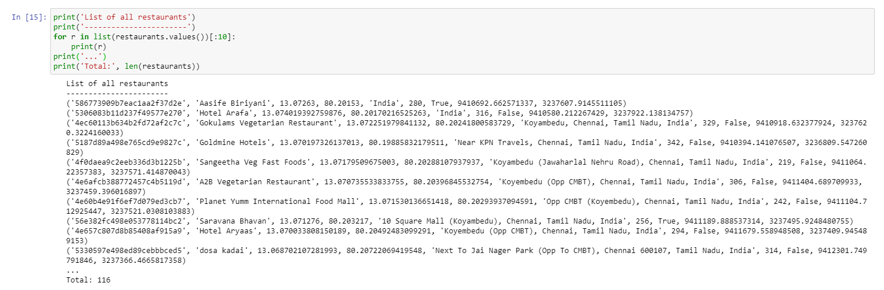

1. Number of restaurants and distance to Vegetarian restaurants in the neighbourhood.

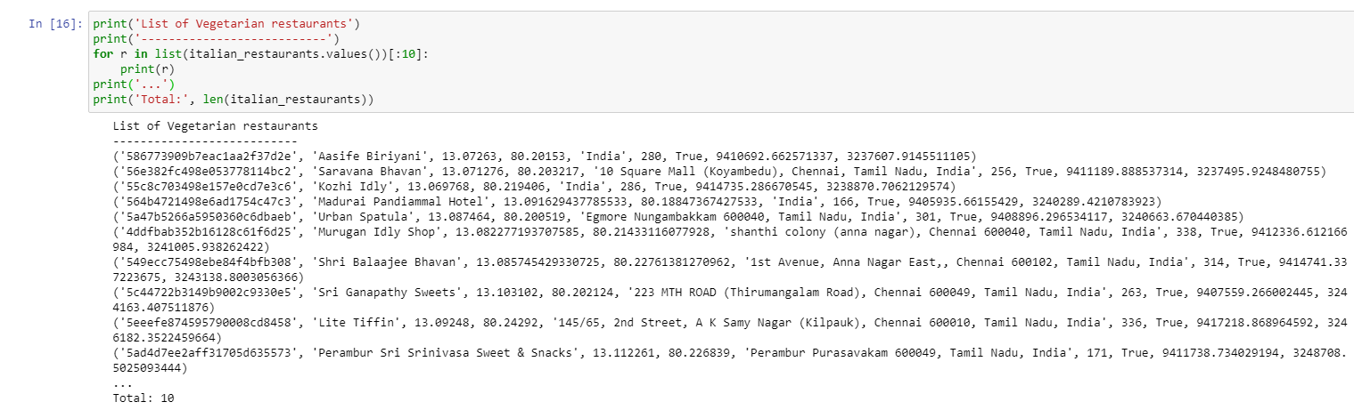

1. Distance of neighbourhood from city centre

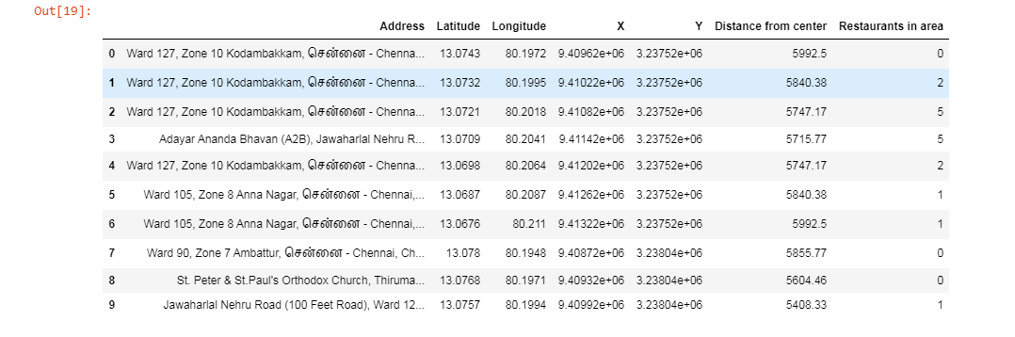

We decided to use regularly spaced grid of locations, centred on city center, to define our neighbourhoods.

Following data sources will be needed to extract/generate the required information:

1. Center of candidate areas will be generated algorithmically and approximate addresses of center of those areas will be obtained using Google Maps API reverse geocoding

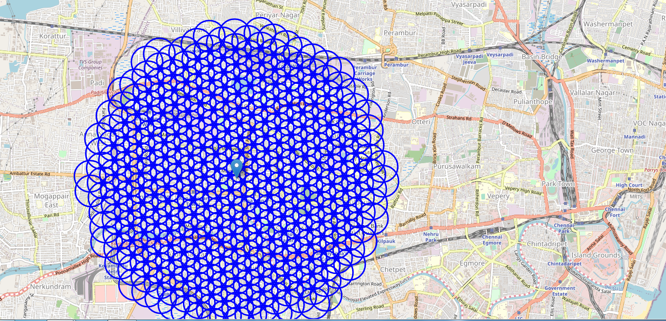

1. Number of restaurants and their type and location in every neighbourhood will be obtained using Foursquare API

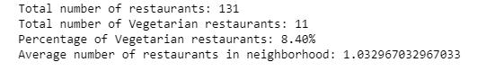

1. Coordinate of Chennai center will be obtained using Google Maps API geocoding of well-known chennai location (Annanagar)

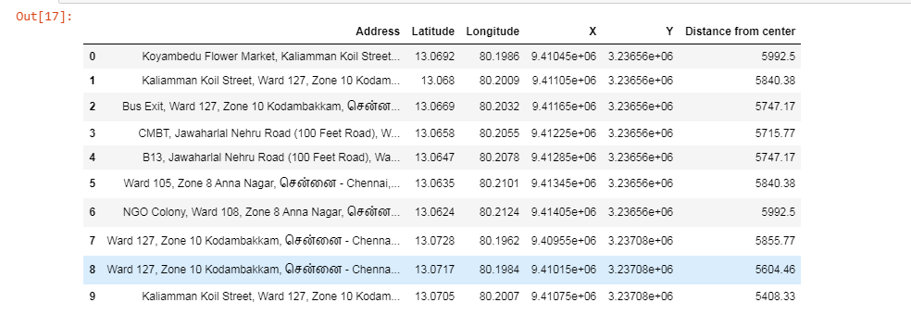

# Methodology

In this project we will direct our efforts on detecting areas of Chennai(Annanagar) that have low restaurant density, particularly those with low number of Vegetarian restaurants. We will limit our analysis to area ~6km around city center.

* In first step we have collected the required **data: location and type (category) of every restaurant within 6km from** Chennai (Annanagar). We have also **identified** Vegetarian **restaurants** (according to foursquare categorization).

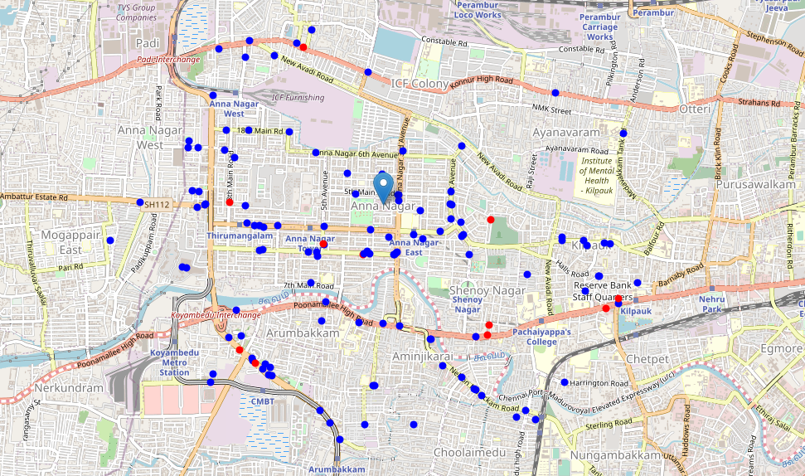

* Second step in our analysis will be calculation and exploration of **'restaurant density'** across different areas of Chennai (Annanagar). - we will use **heatmaps** to identify a few promising areas close to center with low number of restaurants in general (and no Vegetarian restaurants in vicinity) and focus our attention on those areas.
* Heat map of Veg and other restaurant

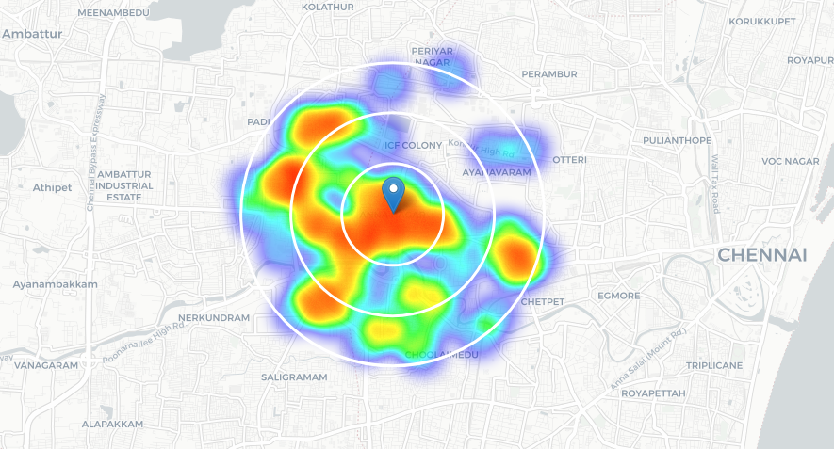

Heat map of only Vegetarian restaurant

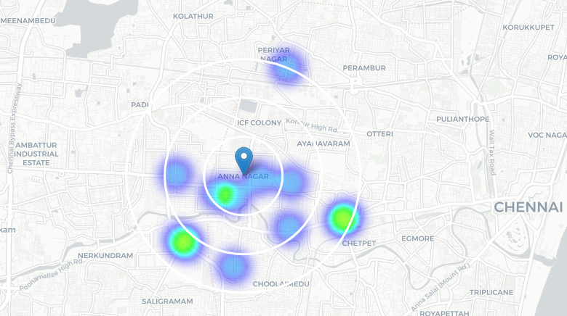

* In third and final step we will focus on most promising areas and within those create **clusters of locations that meet some basic requirements**established in discussion with stakeholders: we will take into consideration locations with **no more than two restaurants in radius of 250 meters,** and we want locations **without** Vegetarian **restaurants in radius of 400 meters.** We will present map of all such locations but also create clusters (using **k-means clustering**) of those locations to identify general zones / neighbourhoods / addresses which should be a starting point for final 'street level' exploration and search for optimal venue location by stakeholders.

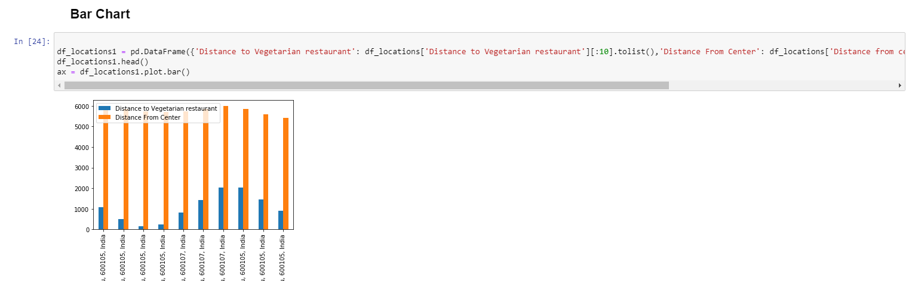

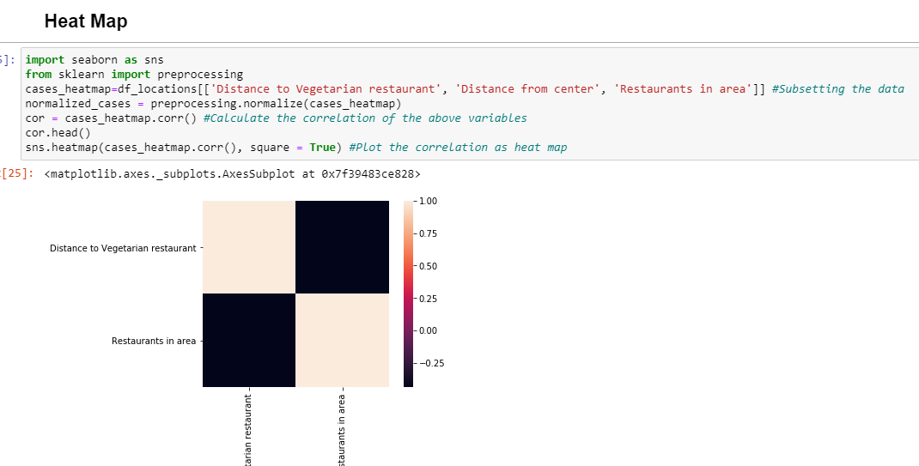

Heat map using map co-ordinates

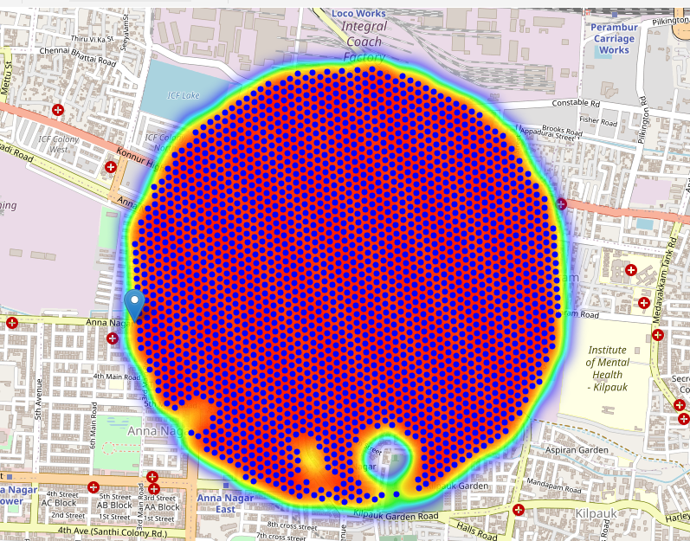

K means clustering

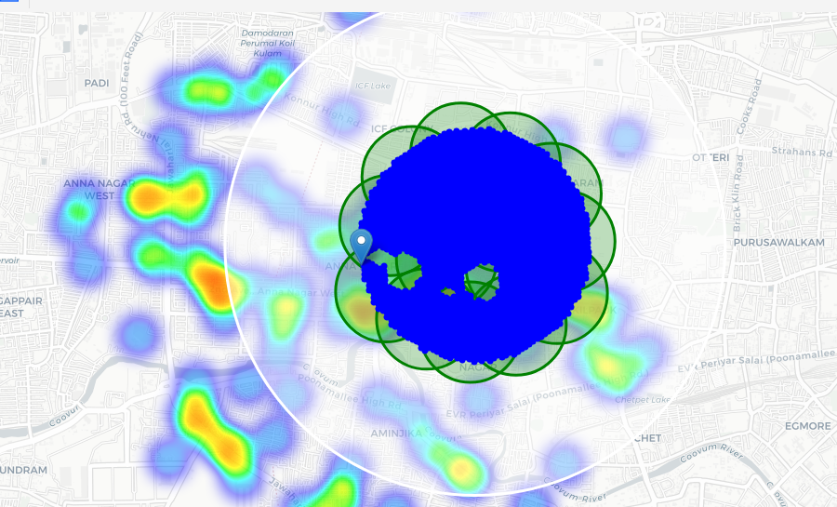

# Analysis

# Results and Discussion

Our analysis shows that although there is a great number of restaurants in Chennai (~2000 in our initial area of interest which was 12x12km around Annanagar), there are pockets of low restaurant density fairly close to city center. Highest concentration of restaurants was detected east, south from Annanagar, so we focused our attention to areas north, north-west. Another borough was identified as potentially interesting (18th Main road Annanagar), but our attention was focused on Annanagar which offer a combination of popularity among tourists, closeness to city center, strong socio-economic dynamics *and* a number of pockets of low restaurant density.

After directing our attention to this more narrow area of interest (covering approx. 5x5km south-east from Annanagar) we first created a dense grid of location candidates (spaced 100m apart); those locations were then filtered so that those with more than two restaurants in radius of 250m and those with an Vegetarian restaurant closer than 400m were removed.

**Below analysis found that map shows the area we finalized which shows less restaurants.**

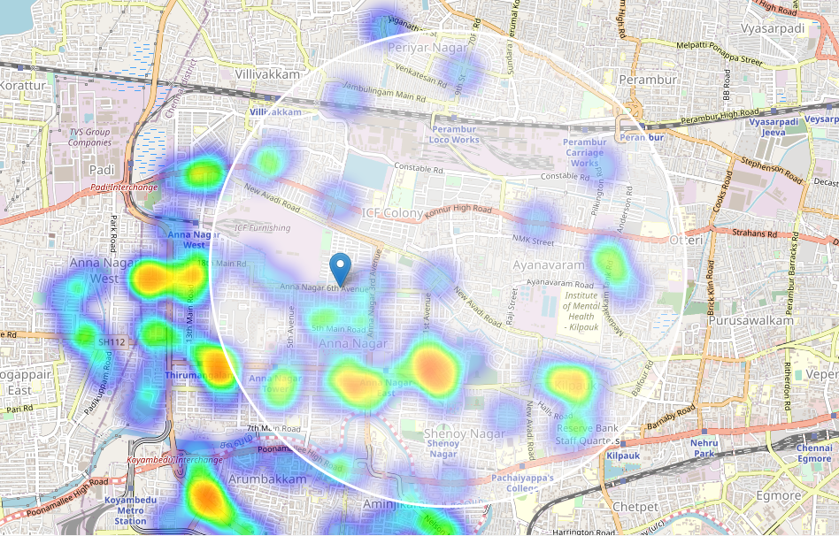

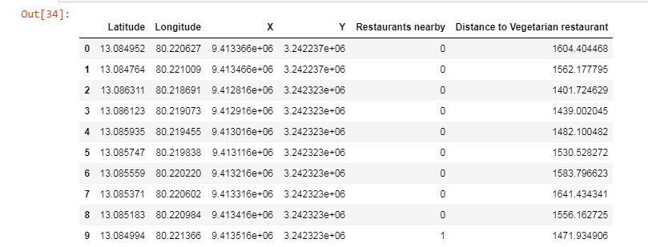

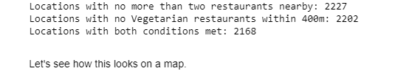

Those location candidates were then clustered to create zones of interest which contain greatest number of location candidates. Addresses of centers of those zones were also generated using reverse geocoding to be used as markers/starting points for more detailed local analysis based on other factors.

Result of all this is 15 zones containing largest number of potential new restaurant locations based on number of and distance to existing venues - both restaurants in general and Vegetarian restaurants particularly. This, of course, does not imply that those zones are actually optimal locations for a new restaurant! Purpose of this analysis was to only provide info on areas close to Chennai Annanagar center but not crowded with existing restaurants (particularly Vegetarian).

It is entirely possible that there is a very good reason for small number of restaurants in any of those areas, reasons which would make them unsuitable for a new restaurant regardless of lack of competition in the area. Recommended zones should therefore be considered only as a starting point for more detailed analysis which could eventually result in location which has not only no nearby competition but also other factors taken into account and all other relevant conditions met.

# Conclusion

Purpose of this project was to identify Chennai Annanagar areas close to center with low number of restaurants (particularly Vegetarian restaurants) in order to aid stakeholders in narrowing down the search for optimal location for a new Vegetarian restaurant.

By calculating restaurant density distribution from Foursquare data we have first identified general boroughs that justify further analysis Annanagar 6th avenue and then generated extensive collection of locations which satisfy some basic requirements regarding existing nearby restaurants.

Clustering of those locations was then performed in order to create major zones of interest (containing greatest number of potential locations) and addresses of those zone centers were created to be used as starting points for final exploration by stakeholders.

Final decision on optimal restaurant location will be made by stakeholders based on specific characteristics of neighbourhoods and locations in every recommended zone, taking into consideration additional factors like attractiveness of each location (proximity to park or water), levels of noise / proximity to major roads, real estate availability, prices, social and economic dynamics of every neighbourhood etc.